Practical 3

Ss 1

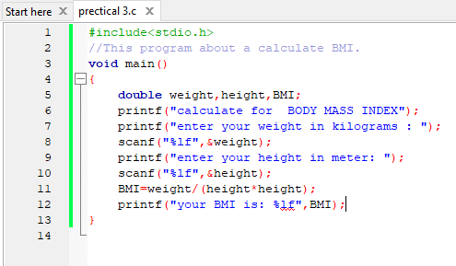

Ss 2

